Generation of Fiducial Coordinates from DICOM Data

**Host Organization:** BARC

**Preamble to the Problem**

**Neuro-registration:** During neuro-registration, bone based markers or fiducials are affixed to the skull (see Figure 1, 2) before imaging. As illustrated in Figure 1, the blue points are fiducials form a body landmarks for reference.

|  |  |
| --- | --- |
|  |  |
| Fig 1: Representation of fiducial marker based pair-point registration. | Fig 2: Fiducials used for neuro-registration in MRI/CT Scan |

**Digital Imaging and Communications in Medicine (DICOM)** is a standard for handling, storing, printing, and transmitting information in medical imaging. It includes a file format definition and a network communications protocol. MRI/CTScan generates the standard DICOM data images. The DICOM images are generated normal to axial axis (in traverse plane), coronal and sagittal planes (refer Figures 3 & 4). DICOM images are a collection of series of images in a particular plane.

|  |
| --- |
|  |
| Fig 3: DICOM, a series of human brain, from base of the skull to top |

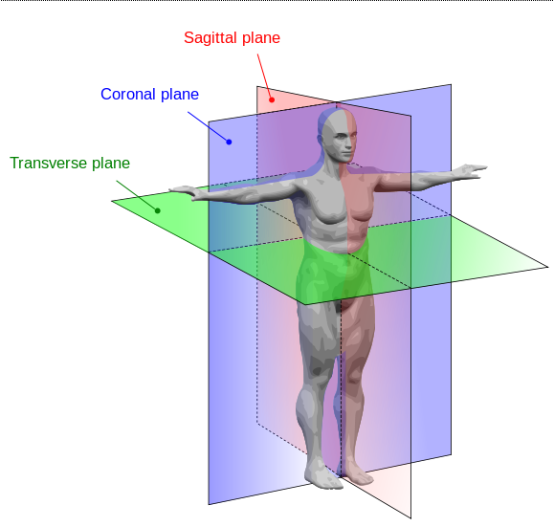

Fig. 4: Human Anatomy Planes

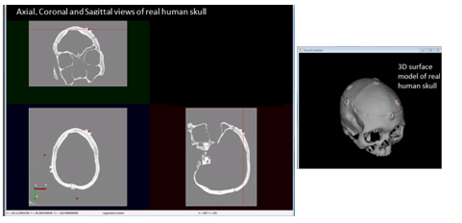

Fig 5: Axial, coronal, sagittal and 3D generated view for a skull phantom with affixed fiducials

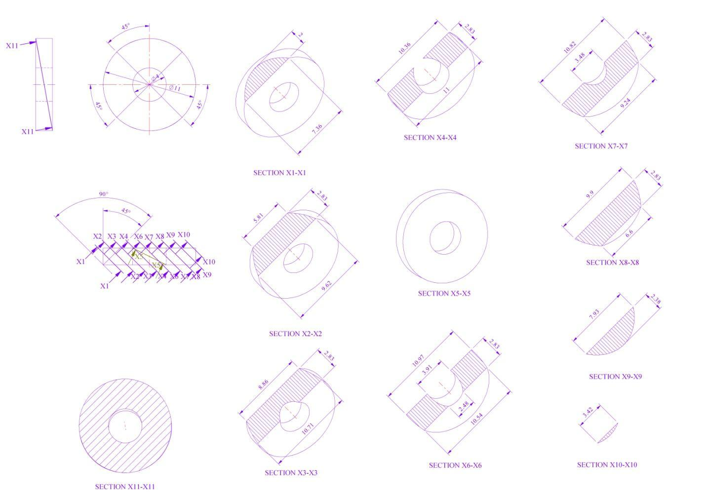

Fig 6: views of section (hatched) with dimension of the fiducial in the image

(example to show the appearance of the section of the fiducial)

**Problem Statement:**

For any given DICOM (MRI/CT scan) series data of the patient with fiducials affixed, it is required to obtain autonomously the number of fiducials and coordinates of the centre points of the fiducials with respect any coordinate reference.

(The problem is to find autonomously the number of fiducials in the series, the three coordinate of the center top surface of the fiducial.)

**Input:**

Given DICOM (MRI/CT scan) series data of the patient with fiducials affixed

**Output:**

Given the DICOM data of the patient/phantom, the algorithm and the software module in C/C++/python needs to be developed which autonomously gives:

1. The total no. of fiducials affixed to the patient.
2. The coordinates (x, y, z) of the top centre (see fig. 7) of all the fiducialsaffixed to the patient with respect to patient coordinate system specified in DICOM.

**Testing:**

The software module developed would be tested for several DICOM data for the accuracy of the coordinates of fiducials.

|  |
| --- |
|  |

Fig 7: Top and Front view of fiducial marker showing the centre point whose coordinates need to be determined with respect coordinate system autonomously